**Girl scouts silver project for Bluebirds at the Plainsboro Preserve**

The Plainsboro Preserve has close to 80 boxes for cavity dwelling species, such as Eastern Bluebirds, to nest in.  The native plants she planted are near these nesting boxes.

Location 1: 13,14,15

Location 2:  20, 21

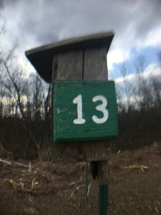

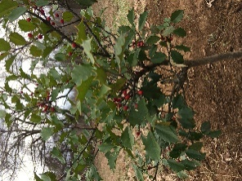

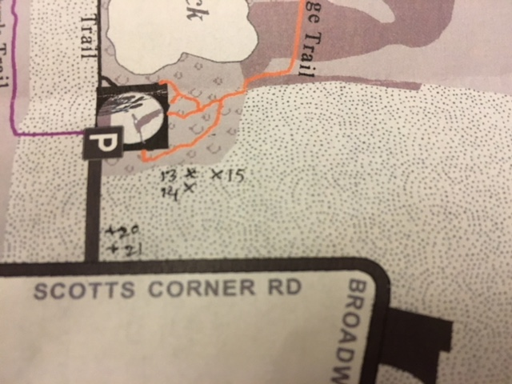

**How you can help bluebirds, and more!**

* Install nesting boxes in your backyard
* Provide dried mealworms during spring and summer
* Plant winter and fall fruit bearing shrubs
* Keep a bird bath open for birds to come

**Wildlife Certification**

Did you know that you can make your backyard a wildlife sanctuary?

Steps

Step 1: Provide cover for your animals

Step 2: Keep water nearby for animals to drink and possibly bathe in

Step 3: Make sure there are several food sources that are available

Step 4: Make sure there are places for animals to breed and raise their young

Step 5: Maintain in a sustainable way

Link to National Wildlife Federation for wildlife certification

[**https://www.nwf.org/Garden-for-Wildlife/Certify**](https://www.nwf.org/Garden-for-Wildlife/Certify)

West Windsor Township Parks



**By**

**Emily Liu**

**Hendrickson Tennis Drive Complex**

This complex has five lighted tennis courts, a playground and a practice wall.

**Address:** Tennis Courts, 199 Hendrickson Dr, West Windsor Township, NJ 08550

**Lewis B. Chamberlin Park**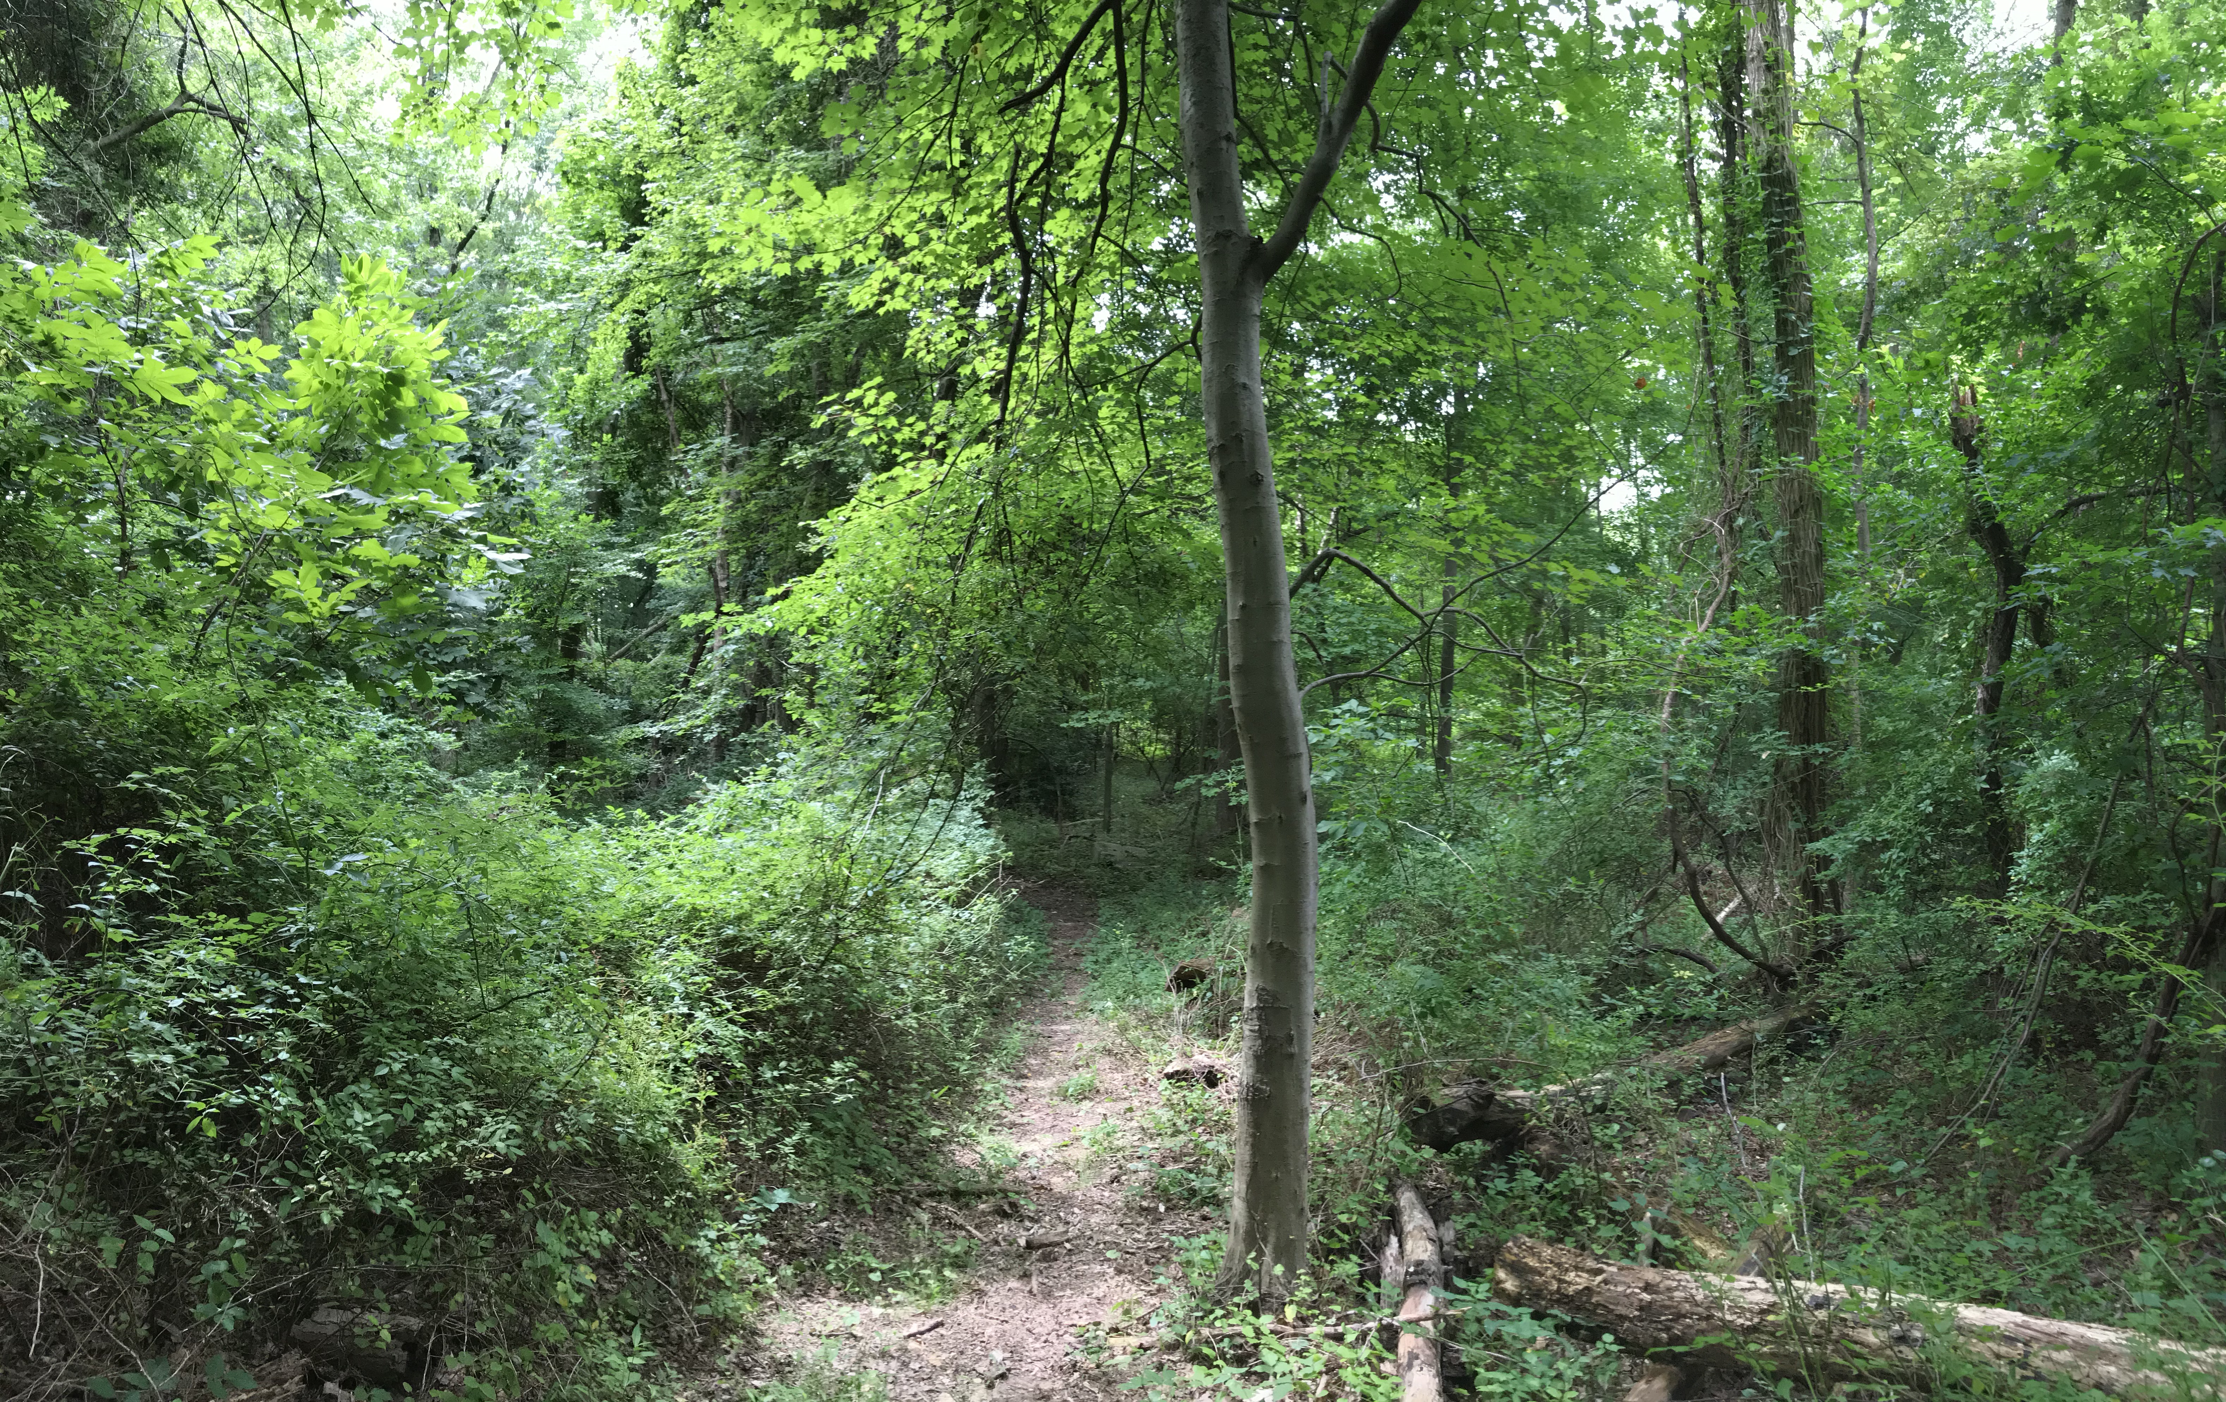

**Eastern Bluebird**

Bluebirds are native to the North-Eastern states of the U.S. They are territorial thrush birds that are easily recognizable with bright blue feathers and a pale orange chest. These birds can live in cold and hot climates, and mate during spring and summer.

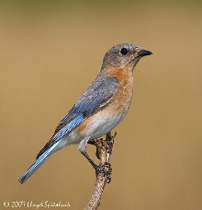 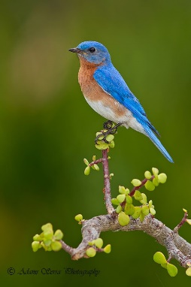

**Female Male**

**Habitat:**

* Meadows, open woods, agricultural fields
* Naturally stay in crevices and small holes in trees

**Diet:**

* Mealworms, caterpillars, crickets, beetles and grasshoppers (during warmer months)
* Berries of native plants, such as American Holly, Bayberry, Staghorn Sumac, Chokeberry, Inkberry, Dogwood and Mistletoe

**Conover Field**



This site includes various sports fields including five soccer fields, five baseball fields and one softball field.

**Address:** Conover Field, 98 N Post Rd, West Windsor Township, NJ 08550

**Dey Forest Park**

Planted with many pine trees, this park is named in tribute to Larry and Lollie Dey, who once farmed this and surrounding property.

**Address:** Carlton Pl, Princeton Junction, NJ 08550

**Duck Pond Park**



This Park includes over 120 acres that is approximately 60 acres of nature preserve and 60 acres of active recreation.

**Address:** 560 Meadow Rd, Princeton, NJ 08540